**Unit- III**

**(Wave Optics)**

**Interference**

The phenomenon of redistribution of light energy in a medium on account of superposition of light waves from two coherent sources is called **interference.**

**Coherent sources:**

Two sources are said to be coherent if they emit continuous light waves of the same frequency or wavelength, nearly of the same amplitude which have either in phase or have constant phase difference.

**Types of coherence:**

**(a)-Temporal Coherence:**

***Temporal coherence*** is a measure of the correlation between the phases of alight wave at different points along the direction of propagation.  Temporal coherence tells us how monochromatic a source is*.*

**.**

**.**

**.**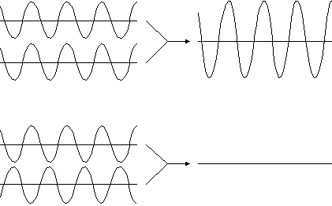

X-axis

B

A

Fig. 3.1

**(b)-Spatial Coherence:**

**Spatial coherence** is a measure of the correlation between the phases of a light wave at different points transverse to the direction of propagation spatial coherence tells us how uniform the phase of the wave front is.

**.**



P

R

**.**

A

B

X-axis

X-axis

Fig. 3.2

**Condition for sustained interference:**

* The two sources of light should emit continuous waves of same wavelength.
* The waves emitted by two sources should either have zero phase difference or constant phase difference.
* For a sustained interference pattern, the two sources must be coherent.

**Interference in thin films:**

The film of transparent material like a drop of oil spread on the surface of water, show brilliant colours when exposed to an extended source of light. This phenomenon can be explained on interference basis. Here interference takes place between rays reflected from the upper and from the lower surface of the film.

**Thin film of uniform thickness:**

1. **Reflection Pattern:**

Let us consider a thin film of thickness t, refractive index µ and a ray AB of monochromatic light of λ is falling on it at an angle i. This ray is partly reflected and partly refracted as shown in Figure 3.3.

Path difference           = (BD + DE)film- (BH)air

= [µ (BD +DE)- BH]air

= [µ(BD + DG + GE) – BH]

= µ (BD + DG)

[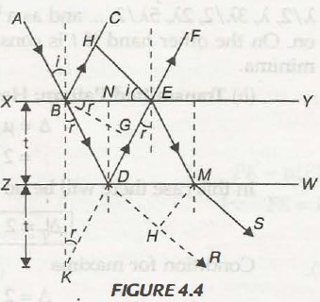](http://www.physics-assignment.com/wp-content/uploads/2012/11/114.png)

Fig. 3.3

As                                                        µGE = BH

BH = EB sin i

GE = EB sin r

µ GE = EB = sin i

µ =

Extend BL and ED to meet at K we have

  LKD = LNDE = r

 Triangles BLD and LKD are congruent

  BD=DK

Then path difference   = µ(BD + DG) = µ(KD + DG)

= µ KG = µ KB cos r

∆ = 2 µt cos r

Now, here since reflection from denser medium, from Stoke’s law additional path difference of λ/2 is taken into account. Thus the total path difference is

∆T = 2 µt cos r – λ/2                                                     … (1)

**Condition for maxima**

∆T = (2 µ cos r- λ /2) = n λ

2 µt cos r = (2n + 1) λ /2         n = 0, 1, 2, 3, ….. .

**Condition for minima**

∆T = (2 µt cos r- λ /2} = (2n + 1) λ /2

1. µt cos r = nλ             n = 0, 1, 2

1. **Transmitted Pattern:**

Here the path difference two rays OEMS and PR will be

∆= µ (DE + EM) – DH

= 2 µt cos r … (2)

In this case there will be no additional path difference so the total path difference

  ∆T = 2 µt cos r

**Condition for maxima**

  ∆ = 2 µt cos r = nλ                              n = 0, 1, 2, 3, ….. .

**Condition for minima**

∆= 2 µt cos r = (2n + 1) λ/2                   n = 0, 1, 2, 3, ……

We find that the conditions for maxima and minima are found in case of transmitted pattern are opposite to those found in case of reflected pattern. Under the same conditions of the film looks dark in reflected pattern it will look bright in transmitted pattern.

**The film is of varying thickness (Wedge shaped thin film):**

Consider the wedge shaped film as shown in Figure. Let a ray from S is falling on the film and after deflections produce interference pattern. The path difference is

∆= [(PF + FE)film + (PK)air]

= µ (PF + FE) – (PK)

= µ (PN + NF + FE) – PK

= µ (NL) = 2 µ t cos (r +θ)

[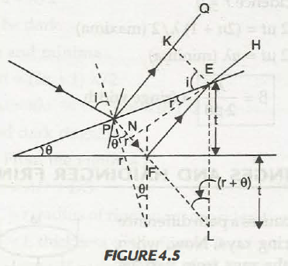](http://www.physics-assignment.com/wp-content/uploads/2012/11/115.png)

Fig. 3.4

 Then total path difference considering refraction from denser medium is taking place

  ∆T = 2 µt cos (r+θ) – λ/2

**Condition for maxima**

  2µtcos (r + θ) = (2n + 1) λ/2                                         n = 0, 1, 2, …..

**Condition for minima**

  2µtcos (r + θ) = nλ                                                       n = 0, 1, 2, 3, …

Hence, we move along the direction of increasing thickness we observe dark, bright, dark----fringes. For t= 0 i.e., at the edge of film ∆ = λ/2 so the film will appear dark. Then width of the fringes so observed can be found

  β = µ tanθ cos (r + θ)

 In case of normal incidence r = 0

2 µt= (2n + 1) λ/2 (maxima)

  2 µt = n λ (minima)

 β = = fringe width

**NEWTON'S RINGS:**

When a piano-convex lens of long focal length is placed on a plane glass plate, a thin film of air is enclosed between the lower surface of 'the lens and the upper surface of the plate. With monochromatic light, bright and dark circular fringes are produced in the air film. These rings are known as Newton’s rings. The experimental set up is shown in fig 3.5.

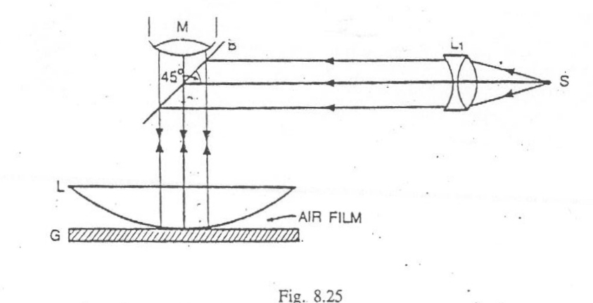

Fig. 3.5

**Theory: Newton's rings by reflected light**

Suppose the radius of curvature of the lens is R and the air film is of thickness t at a distance of OQ = r, from the point of contact O.

Here, interference is due to reflected light. Therefore, for the bright rings



Where n = 1, 2, 3, …… etc.

Here q is small, therefore cos q = 1 and for air µ = 1



For the dark fringe



Where n = 0, 1, 2, 3, …… etc.

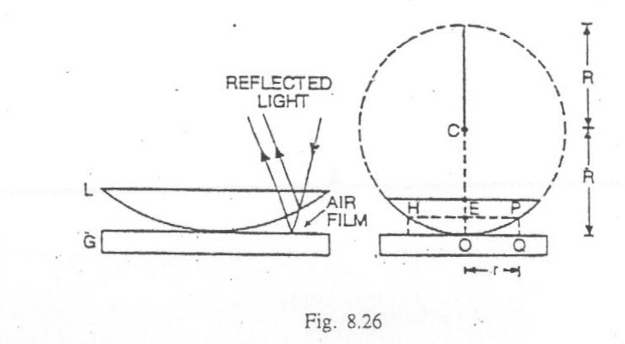

Fig. 3.6

In Fig. 3.6,



Substituting the value of *t* in equations *(ii)* and *(iii),* For bright rings



For dark rings



When n = 0, the radius of the dark ring is zero and the radius of the bright rings is  , therefore, the center is dark. Alternately dark and bright rings are produced (fig. 3.7).

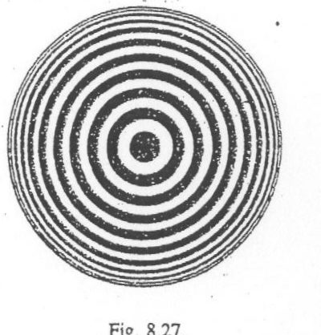  
 Fig. 3.7

Further if Dn is the diameter of dark ring then

(Dn)2 = 4nλR

Or                                            Dn= √(4 λR) √n

Dn  α √n

Thus, the diameter of dark rings are proportional to the square root of natural numbers.

If Dn is the diameter of bright ring then

(For air, µ = 1)

Or

i.e., Dn α .

Thus, the diameter of bright rings are proportional to the square root of the odd natural numbers.

**Applications:**

**(a) Measurement of Wavelength of light by Newton’s Rings:**

 For nth dark rings we know

For (n + p)th dark ring, the above relation can be written as

 Then     

Thus, measuring the diameters and knowing p and R, λ can be measured.

**(b) Measurement of Refractive Index of Liquid by Newton’s Rings**

 For this purpose liquid film is formed between the lens and glass plate.

 We have, as above,

which give

Or

One can see that rings contract with the introduction of liquid.

**Diffraction**

Light travels in straight lines. If an opaque obstacle or aperture be placed between a source of light and screen the light bends round the corners of the obstacle or aperture, and enters the geometrical shadow. This bending of light is called diffraction. Diffraction phenomena are divided into two groups;

1. **Fresnel’s diffraction:**

In this class either the source or screen or both are at finite distance from the obstacle and thus distances are important. Here the incident wavefronts are either spherical or cylindrical.

1. **Frounhofer’s diffraction:**

In this class both the source and the screen are at infinite distance from the obstacle and thus inclination are important not the distances the wavefront is plane one.

**Fraunhofer’s diffraction at a single slit:**

Let S is a source of monochromatic light of wavelength ‘A, L is collimating lens AB is a slit of width a, L’ is another conversing lens and XY is the screen light coming out from source and passing through slit is focused at the screen. A diffraction pattern is obtained on the screen which consists of central bright band having alternate dark and bright bands of decreasing intensity on both the sides. The complete arrangement is shown in Figure 3.8.

[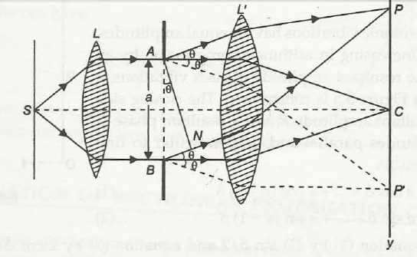](http://www.physics-assignment.com/wp-content/uploads/2012/11/122.png)

Fig. 3.8Fraunhofer’s diffraction at single slit

**Analysis and explanation**:

The diffracted ray along the direction of incident ray are focused at C and those at an angle θ and focused at P and P’.For the intensity at P, let AN is normal to BN, then path difference between the extreme rays is

  ∆ = BN = AN sin θ = a sin θ

Or

Let AB consists of n secondary sources then the phase difference between any two consecutive source will be

The resultant amplitude and phase at P will be

Substituting the value of δ we have

Where A = na   and

The corresponding intensity is

**Condition of minima:**

For minima I = 0

The intensity will be 0 when or sin α = 0

 i.e., α  = ± mπ

  π a sin θ/λ = ± mπ

a sin θ = ± mλ

**Condition of maxima**:

The intensity will be maximum when

i.e., α = tan α

The value of a satisfying this equation are obtained graphically by plotting the curve y = α and

y = tan α on the same graph (Figure 3.9). The point of intersection will give

α = 0, ± 3π/2, ± 5 π /2, ± 7 π /2,

=0, ± 1.43 π, ± 2.462 π, ± 3.471 π,

Fig.3.9: Graphical representation of positions of secondary maxima’s in the diffraction

 α = 0 correspond point to central maximum whose intensity is given as

  I=   limit A2 [ sin2 α / α2 ]= A2 = I0

 The other maxima are given by

  a sin θ = (2m + 1) λ/ 2

 and their intensities as

  m = 1:     I1 = A 2 (sin 3π/2) 2=  4 I0/ 9π2 =  I0 /22

 m = 2:      I2 = 4I0/25π2 = I0/61

 m3 = I3 = 4I0/ 49π2 = I0/121 and so on

Thus the intensities of the successive maxima are in the ratio

Or

The diffraction pattern consists of a bright central maximum surrounded alternatively by minima maximum is shown in fig. 3.10.

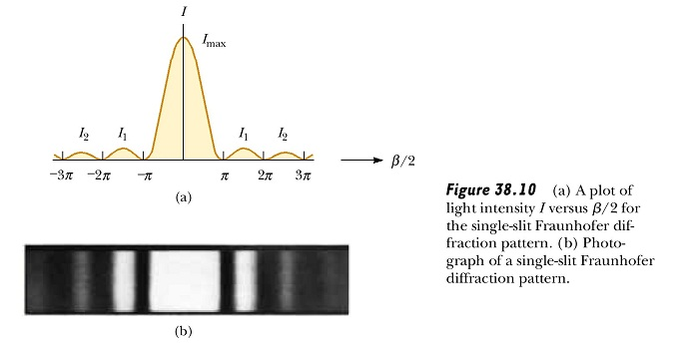

0

α

Fig.3.10

**Double Slit diffraction:**

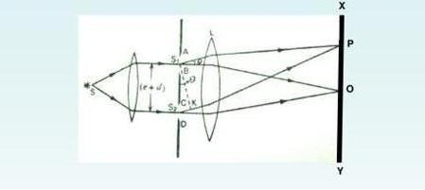

Fig. 3.11

Let AB & CD are two slits, each of width e, seperated by opaque space d.The distance between the corresponding points of the two slits is (e+d).By Huygen’s principle every points in the slit AB & CD sends out secondary wavelets in all directions.From the theory of diffraction due to single slit , the resultant amplitude due to wavelets diffracted from each slit in the direction θ is

Where A is a constant and α =

Therefore the resultant amplitude amplitude at point P on the screen will be result of interference between two waves of same amplitude Asinα/α and having a phase difference δ.The path difference between wavelets from S1 and S2 in the direction θ.

S2K= (e+d)sinθ

Phase difference δ =

The resultant amplitude R at P can be determined by the vector amplitude diagram(fig. 3.12) which gives

OB2 OA2+AB2+2(OA)(AB)cosθ

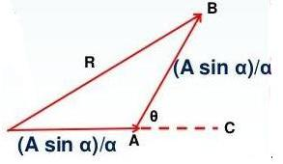

Fig. 3.12

R2= A+A+2(

R2 = (2+2cosδ)

R2 = 4cos2

R2 = 4cos2β

where β = = (e+d)sinθ

Therefore, the resultant intensity at P is

I = R2 = 4cos2β

Thus the intensity in the resultant pattern depends on two factors:

1. which gives the diffraction pattern due to each individual slits.
2. cos2β which gives the interference pattern due to diffracted light waves from the two slits.

The diffraction term gives the central maxima in the direction θ=0 , having alternately minima and subsdiary maxima of decreasing intensity on either side(fig. 3.13).

The minima are obtained in the direction given by α =0

sinα = 0 , α= ± mπ

esinθ = ± mπ (where m= 1,2,3……., except zero)

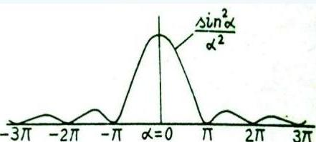

Fig. 3.13

The interference term cos2β gives the set of equidistant dark and bright fringes.The bright fringe obtained in the direction given by

cos2β = 1

or β = ± nπ

Where β = (e+d)sinθ = ± nπ

(e+d)sinθ = ±nλ , Where n = 0,1,2……….

The various maxima corresponding to n = 0,1,2,3…… are zero order first order and second order ………… maxima(fig. 3.14).

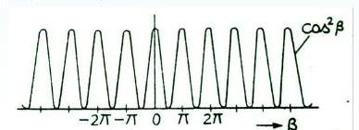

Fig. 3.14

The intensity distribution, in the resultant diffraction pattern is a plot of the product of constant term 4A2, diffraction term sin2α/α2 and interference term cos2β, is shon in fig. 3.15.

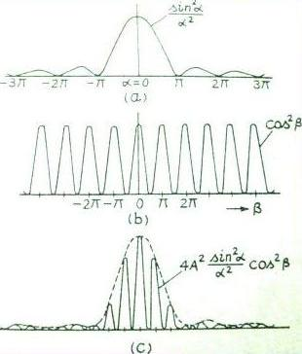

Fig. 3.15

**N-slit Fraunhoffer diffraction:**

Let a parallel,collimated beam of monochromatic light of wavelength λ be incident normally on N paralel slits(grating) each of width a and seperated by an opaque distance b (fig. 3.16).The sum of a & b is known as grating element.

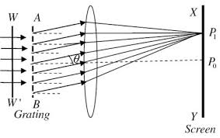

Fig. 3.16

Consider that each slit in the grating is equivalent to an individual coherent source which is placed at the middle of each slit and sending a single wave of amplitude Asinα/α in the direction θ, Where α= .

The path difference between two successive slit is given by

Δ = (a+b) sinθ……………………….(1)

The phase difference is given by

= 2β(say)…………..(2)

The resultant amplitude due to N-slit is given by

R’ = R = A…………..(3)

And I = R’2 = A2……………..(4)

**Position of principle maxima:**

The direction of principal maxima are given by

  sin β = 0, i.e., β = ± nπ, where n = 0, 1, 2, 3, … ·

π/λ  (a + b) sin θ = ± nπ => (a + b) sin θ = ± n λ … (5)

If we put n = 0 in equation (3), we get θ = 0 and equation (3) gives the direction of zero order principal maximum. The first, second, third, … order principal maxima may be obtained by putting n = 1, 2, 3, . .. in equation (5).

**Position of minima:**

The intensity is minimum, when

sin Nβ = 0; but sin β :# 0

Therefore

Nβ = ± mπ

N π/λ (a + b) sin θ = ± mπ

N (a + b) sin θ = ± mλ ..……………,(6)

Here m can have all integral values except 0, N, 2N, 3N, ..because for these values of m, sin β = 0 which gives the positions of principal maxima.

It is clear from equation (6) that form= 0, we get zero order principal maximum, m = 1, 2, 3,4,----,(N -1) gives minima governed by equation (4) and then at m = N, we get principal maxima of first order. Thus, there are (N – 1) minimum between two successive principal maxima.

**Secondary Maxima:**

The above study reveals that there are (N- 1) minima between two successive principal maxima. Hence there are (N -2) other maxima coming alternatively with the minima between two successive principal maxima. These maxima are called secondary maxima.

For secondary maxima

dI/dβ=0

i.e., tan Nβ = N tan β

To find the intensity of secondary maximum, we make these of the triangle shown in Figure 3.17, we have

sin Nβ = N tan β/√ (1+N 2 tan 2 β)

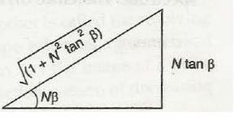

1

Fig. 3.17

Therefore

Putting this value of in   equation (4), we get intensity of secondary maxima  as

This indicates the intensity of secondary maxima is proportional to  whereas the intensity of principal maxima is proportional to N2.

The intensity distribution of plane diffraction grating is shown in figure 3.18.

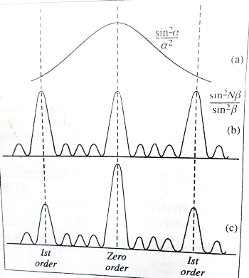

Fig. 3.18

**Absent Spectra:**

The minima of single slit pattern are obtained in the direction given by.

a sin θ= mλ                                                     …(1 )

where m = 1, 2, 3, …… excluding zero but the condition for nth order principles maximum inthe grating spectrum is

(a + b) sin θ = nλ                                            … (2)

If the two conditions given by equation (2) are simultaneously satisfied then the direction in which the grating spectrum should give us a maxima, every slit by itself will produce darkness in that direction i.e., the diffraction minima. Hence the resultant intensity will be zero. Such order will be absent from spectrum. These spectra are known as absent spectra.

Therefore dividing equation (2) by equation (1)

(3)

This is the condition for the absent spectra in the diffraction pattern

If a= b then from eqn. (3) n = 2m. Therefore for m = 1, 2, 3 etc. the 2nd, 4th, 6th etc., orders will be absent from the spectra.

For b = 2a, we have n=3m. Therefore for m = 1, 2, 3 etc. the 3rd, 6th, 9th etc., orders will be absent from the spectra.

**Resolving power :**

When two objects are very close to each other, it may not be possible for our eye to see them separately. The minimum separation between two objects that can be resolved by an optical instrument is called resolving limit of that instrument. The resolving power is inversely proportional to the resolving limit.

**Rayleigh Criterion of Resolution:**

According to Lord Rayleigh’s criterion two nearby images are said to be resolved if the position of central maximum of one coincides with the first minima of the other or vice versa.

[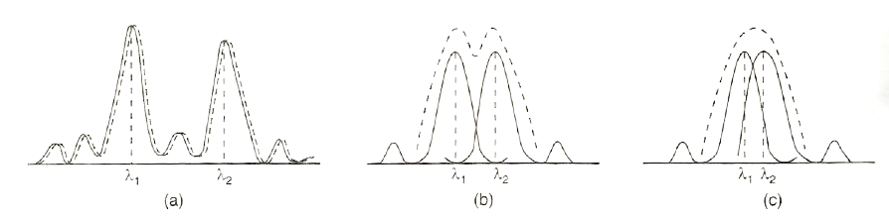](http://www.physics-assignment.com/wp-content/uploads/2012/11/125.png)

Fig. 3.19(a) Fig. 3.19(b)

To illustrate this let us consider the diffraction patterns due to two wavelengths λ1 and λ2. Consider that (λ) is such that central maximum due to one falls on the first minima of the other as shown in fig. 3.19(a). The resultant intensity curve shows a distinct dip in the middle of two central maxima. This situation is called just resolved. If the (λ1-λ2) is very small such that they come still closes as shown in fig. 3.19(b). The intensity curves have sufficient overlapping and two images cannot be distinguished separately. This case is known as unsolved.

**Resolving power of grating:**

Resolving power of grating represents its ability to form separate spectral lines for wavelengths very close together. It is measured by , where dλ is the smallest wavelength difference that can be just resolved at wavelength λ.

Let a parallel beam of light of two wavelengths λ and (λ + dλ) be incident normally on the grating.

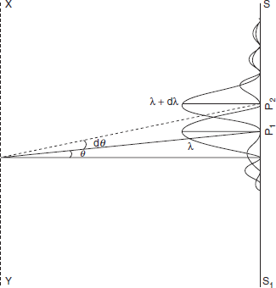

Fig. 3.20

If nth principal maxima of λ is formed in the direction θ, we have

Let the first minima adjacent to the nth maxima be obtained in the direction (θ + dθ). The grating equation for minima is

Clearly, the first minima adjacent to the nth principal maxima in the direction of θ increasing will be obtained for m = (nN + 1). Therefore, if this minima is obtained in the direction (θ + dθ), we have

or

By Rayleigh’s criterion, the wavelengths λ and (λ + dλ) are just resolved by the grating when the nth maxima of (λ + dλ) is also obtained the direction (θ + dθ). Then we have

Thus,

Or

But is the resolving power of grating. Therefore resolving power of grating is equal to the total number of rulings on the grating and the order of the spectrum.

**FAQ’S**

**Short answer type questions**

1. What do you mean by coherent source?
2. What is the main condition to produce interference of light?
3. Distinguish between Fresnel and Fraunhofer type of diffraction.

**Long Answer type questions**

1. Discuss the phenomena of interference of light due to thin films and find the condition of maxima and minima. Show that the interference patterns of reflected and transmitted monochromatic light are complementary. **[2002,2009,2010]**
2. Discuss the formation of the Newton’s rings by reflected monochromatic light. Prove that in reflected light the diameters of bright rings are proportional to the square roots of odd natural numbers**.[2015]**
3. Discuss the phenomena of Fraunhofer diffraction at a single slit and show that the relative intensities of successive maxima are nearly **[2002,2005,2009]**